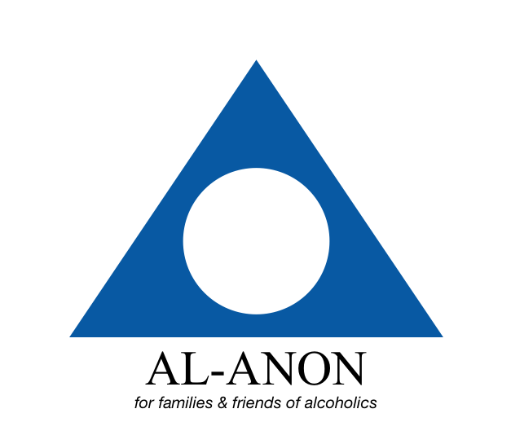

For the most up-to-date meeting schedule in Davis, California, please go to:
https://localwiki.org/davis/Al-Anon

You can also contact our Davis Outreach Coordinator:
call/text: 530-554-4336
email: alanon.davis.outreach@gmail.com

