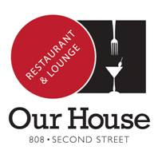
$30 Three Course Dinner
First Course
Choice of:
Cream of Five Onion
Tomato Basil Bisque
Soup du Jour
Chopped Caesar w/ Bacon & Tomatoes
Spinach Salad
Butter Leaf Salad
Fried Brussel Sprouts w/ Chili-Mint Vinaigrette
Grilled Artichoke w/ Rosemary Aioli
Tequila Lime Beef w/ Lime Dipping Sauce

Second Course
Choice Of:
Lemon Ricotta Gnocchi w/ Pancetta
Macque Choux w/ Prawns
Chicken Picatta
Baby Back Pork Ribs w/ Sweet Garlic Soy Glaze
Pork Chop w/ Cabernet-Cherry Demi Glaze
BBQ Salmon w/Soy, Mint & Cilantro Sauce
14 oz New York Steak w/ Chimichurri Butter

Third Course
Choice of Dessert

