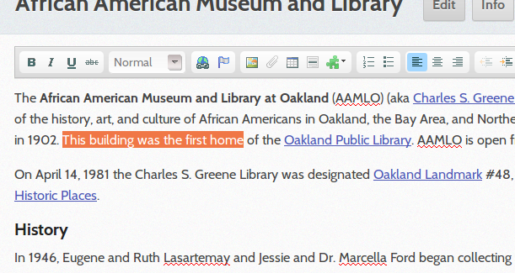
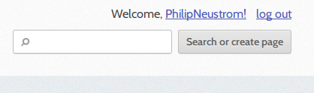
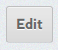
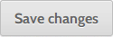
How to Edit LocalWiki

To begin editing the wiki, first search for the entry you would like to edit (e.g., Downtown).

You will see a list of pages that might match your entry. If there's an exact match, click the link for the entry you want to edit, then go to the Edit a Page section to start.

If there is no exact match, you will find a button to Create this page. Instructions to do this are farther down.

Edit a Page

Editing a page is very simple. When you find the entry you want to edit, click on the "Edit" button right next to the page's name on top. It looks like this:

You'll see a space to add text and above that an editing toolbar with formatting options (see right).

In the text box, you can add or replace text, just like in a word processing program like MS Word. When you save, the final entry will look very similar to the way you typed it.

In addition to adding text, you can upload images, insert links, format text, and more. There are options for all of these in the editing toolbar. To see what a button does, hover your mouse over it.

Before saving, you can add a comment describing what you changed (e.g., “added some history”). This gives a summary for other people about what changed with each save. This is entirely optional though.
Once you're done editing, click the button at the very bottom of the page. You can exit the editing screen at any time by clicking the “Cancel” button next to the “Save changes” button.

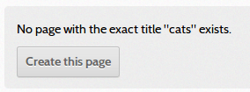
Tags! At the bottom of every entry, you'll see an “Edit tags” button. If you click this, you can add categories for your entry (e.g., “history,” “neighborhood,” “store”). Type the tag and hit “Enter” after you are done writing it. You can add multiple tags this way and then click “Save” when you're done. If you want to see a list of all the entries that have the same tag, click the tag itself.

Create a Page

What happens when you search for a page and the entry doesn’t exist yet? You can create it!

1. In order to create a new page, first search for the title of the entry you want to create. For example, if you wanted to create an entry about “downtown,” search for “downtown.”
2. You will see a list of pages that might match your entry. If there's an exact match, click the link and edit the entry. If there's no exact match, you will see a button with the option to “Create this page.”
3. Click “Create this page” to start editing your new page. Editing instructions are above.

Create a Map
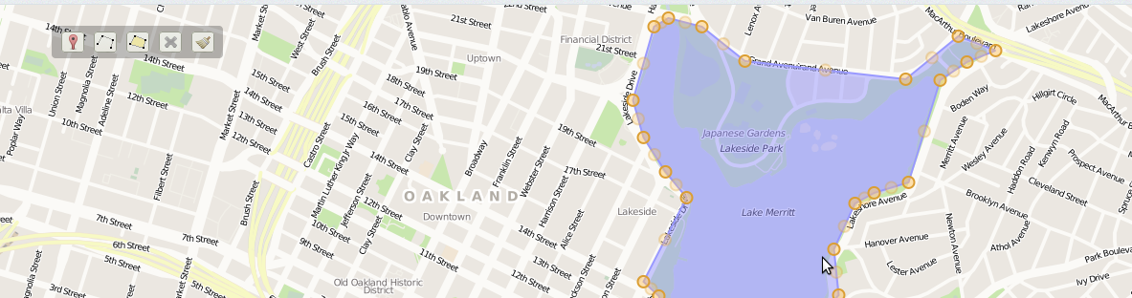
To add a map to an entry, go to the entry, click “Edit,” then click “Edit Map” at the bottom of the screen. You can zoom in and out of the map using the plus/minus buttons, and move the map using either the up/down arrows or clicking on and dragging the map.

Use this marker to add points.
Use this tool to draw lines. Click the icon then click on the map to start the line. You can continue to add as many pieces to your line as you want. Double click on your last point to end the line.
Use this tool to draw a region (e.g., parks, neighborhoods, etc.). Click the icon then click on your starting point. Continue until you create a solid shape. To finish, double click on your last point.
This is the delete tool. Select it and click the elements you want to delete from the map.
This tool will clear everthing from the map.

When you are finished making your map, click Save changes to save.

